Proceedings of the ASME 2024
International Mechanical Engineering Congress and Exposition
IMECE2024
August 25-28, 2024, Washington, DC, USA

IMECE2024-####

REACTIVE Navigation of Multirobot Systems in 2D Vector Fields

Christopher Waight², Christopher Kitts¹
¹Santa Clara University, Santa Clara, CA, USA
²Santa Clara University, Santa Clara, CA, USA

Abstract
Reactive Navigation maneuvers a robot by immediately responding to its current sensor readings. It allows for the exploration of unknown environments and stochastic environments with moving features of interest. Research in this multirobot reactive navigation primarily involves navigation in scalar field environments, but reactive navigation of multirobot systems in vector fields is in its infancy, with mostly an exploration into extrema seeking. This document describes regions of interest within 2-dimensional vector fields, a technique for modeling vector fields in simulation, control primitives that describe the robot’s reaction, an updated test bed, and results in hardware. Regions of interest including local extrema points, stagnation points, equi-magnitude contours, and separatrix trajectories It recaps cluster control formulation, a centralized method of formation control for multirobot systems which is used in this research. A few control primitives which rely on purely reactive control are developed to maneuver the multi-robot system to features of interest in vector fields. These control primitives are then demonstrated in several simulated environments, and repeated on the test bed. The performance of each control primitive in simulation and on the testbed is then discussed. It was found that all primitives in simulation were reproducible on the test bed.
Keywords – Adaptive Navigation, Vector Fields, Multirobot Systems, Cluster Space.

Introduction
Multirobot systems are coordinated groups of robots that often have capabilities beyond that of individual robots [1][2]. In a multirobot system, each robot offers speed, precision, repeatability, safety, and resilience to extreme environments [3]. When grouped into a multirobot system, the system has additional advantages such as redundancy, expanded coverage, and collaborative task execution, which is vital for missions ranging from search and rescue to environmental monitoring [4-5].
Adaptive Navigation methods update a vehicle’s desired trajectory in real time using environmental readings as inputs [28]. These methods retain the benefits of being able to withstand harsh conditions, but further enabling robots to navigate in environments dynamic or communication-restricted environment [6]. Use cases for this include tracking contamination areas, oil spills and source points [12-15], and plume front tracking [16].
Multirobot Adaptive navigation in scalar field environments is well studied in both simulation and practice. This includes formation control using centralized and decentralized architectures, and developing control strategies for extremum seeking, contour following, and other regions of interest [7-11]. Extending these methods to vector field environments is in its infancy, with most of the work done is using artificial vector fields for formation control [17-19]. There are only a few using distributed vector readings from a multirobot system in a vector field [20-23]. It has been shown in simulation that control primitives for multirobot systems exist, including methods for navigating to the fastest flowing point in a stream, navigating to the center of a vortex, sink or source, as well to the center of a sinking vortex [13]. Indoor test beds have also been developed to demonstrate a few of these primitives [22]. This extension to vector fields provides multirobot systems with new methods to navigate extreme environments in fluid flow fields such as rivers, oceans, and aerial spaces [21-24]. Moreover, this extension allows for adaptive navigation methods to be used in extraterrestrial settings autonomous navigation through non-uniform gravitational fields, magnetic fields, and thermal gradients, and other vector fields, such as during asteroid mining [25] [26].
In this paper, we extend research in vector field adaptive navigation using multirobot systems with centralized control to locating additional features of interest using newly developed control primitives. Section 2 covers the high-level control architecture of the multi-robot system. In Section 3, the paper discusses different basis for creating vector fields using superposition and introduces a list of features of interest. Section 4 defines control primitives used to navigate to each feature of interest in a purely reactive manner. Section 5 discusses the performance and limitations of these control primitives in simulated environments. Section 6 closes this work with a few ideas for future research. Section 7 acknowledges all who made this research possible.

MATERIALS AND METHODS

2.1 MultiRobot Control Architecture
The multirobot system utilizes a hierarchical control architecture with three main layers. At the lowest level, the Robot System Controller manages individual robot operations, including sensor data acquisition and motor actuation. The Formation Controller, at the mid-level, governs the collective motion of the robot fleet, maintaining the desired formation and trajectory. Finally, the Reactive Navigation Layer acts as the high-level decision-making unit, processing distributed sensor readings to determine the fleets’ immediate response with predefined reactive behaviours. This architecture for multirobot systems has been successfully demonstrated in a variety of studies, including finding local extrema and contour following in scalar fields, and in maneuvering a two-balloon system in a 3D environment.
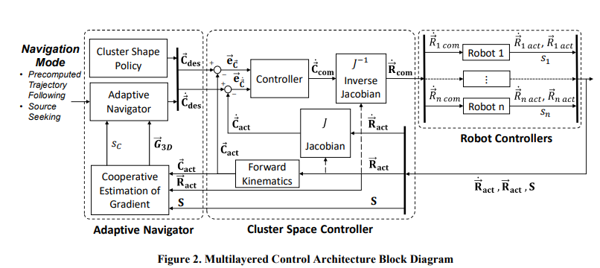
FIGURE 1: MULTILAYERED CONTROL ARCHITECTURE BLOCK DIAGRAM

The adaptive navigation layer hosts the control primitives. It tells the cluster space layer which shape policy to use and commands the entire cluster in a direction according to control primitive. It includes two primitives known as, ‘the direction follower’ and the ‘vector to scalar’ primitive. Thes direction follower averages all directions, and follows that, while the vector to scalar converts the vector reading to a magnitude reading only, then using scalar field primitives instead. [14]. It also has a new technique that we are dubbing the ‘median filter technique’, which finds the middle vector, and follows that direction with the magnitude guiding the feedback gains.
For the formation controller layer, a cluster space controller was used. Cluster Space control is a technique developed by Dr. Chris Kitts of Santa Clara University. In this technique, all robot positions are described geometrically relative to a cluster frame. A generalized cluster in a 2-dimensional plane can be seen in figure 2.
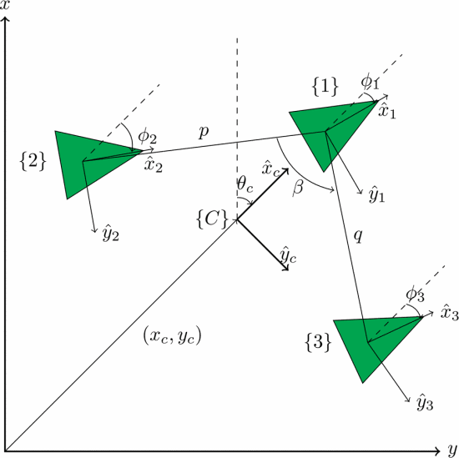
FIGURE 2: A 3-ROBOT CLUSTER WITH CLUSTER FORMATION VARIABLES
For this research, a 3 robot cluster with the formulation used in figure 2 was used. The cluster values, p=0.5, q = 0.5, and β= 0.359 were chosen arbitrarily as values for the cluster variables.
The robot controllers receive velocity commands, and adjust the wheels accordingly. It also saves the sensor tuning and calibration profiles, and converts the raw readings into best estimates of the truth. In simulation, the robotos in the robot controller layer are modelled as massless point objects with first order dynamics.

2.2 Creating Simulations
The Laplace Equation, given by:
$$\begin{aligned}∇^{2} ϕ=0 \#\left(1\right)\end{aligned}$$
Where $∇^{2}$ is the Laplace operator and $ϕ$ is a scalar potential function. The gradient of the potential functions can be described as vectors. Furthermore, the inherent linearity property of the solutions allows for superposition of solutions. This motivates the idea that solutions to the Laplace equation can be effectively superimposed to model complex vector fields. This methodology was pivotal in creating model environments for our simulations.
Potential functions that satisfy the Laplace equation include uniform flows, sinks, sources, dipoles, and vortices, under the assumption of ideal conditions.
Uniform flows are the simplest solution, representing a constant velocity in a given direction. This field could be superimposed with other uniform flows over a smaller region to create non-uniform flows, such as an increased current in the middle of a river flowing faster (see Fig 3).
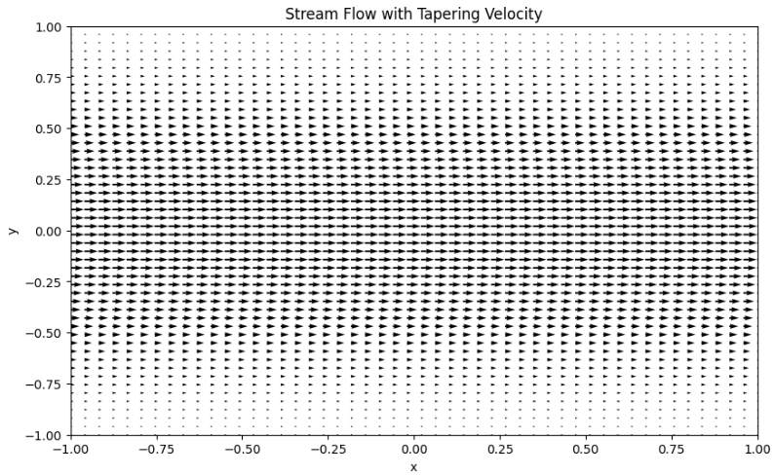
FIGURE 3: MODELLING A RIVER WITH A STRONG CENTRE FLOW AS SUPERIMPOSED UNIFORM FLOWS
Sinks and sources have potential functions that get stronger near the point of origin. This can represent points where fluids enter or exit the flow field, or the source of a gravitational point mass or magnetic pole, modelled with a magnitude of r⁻² and pointing in a direction away from or towards the extrema point for sources and sinks respectively (see Fig 4). Examples of these in nature include hot springs, celestial bodies, and planetary magnetic poles.
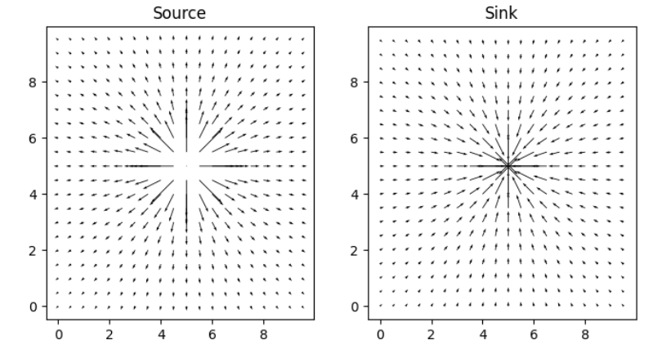
FIGURE 4: A SOURCE POTENTIAL VECTOR FIELD
Vortices (free and fixed) are also valid potential fields that satisfy the Laplace equation. These can be used to model whirlpools and atmospheric pressure systems, or the wake of an object in a uniform flow.
Magnetic dipoles can also be modeled as a fundamental solution to the Laplace equation. Alternatively, dipoles can be modeled as a source point that is located infinitesimally close to a sink point (see Fig 5). In this figure, the vector sizes are normalized for better visualization.

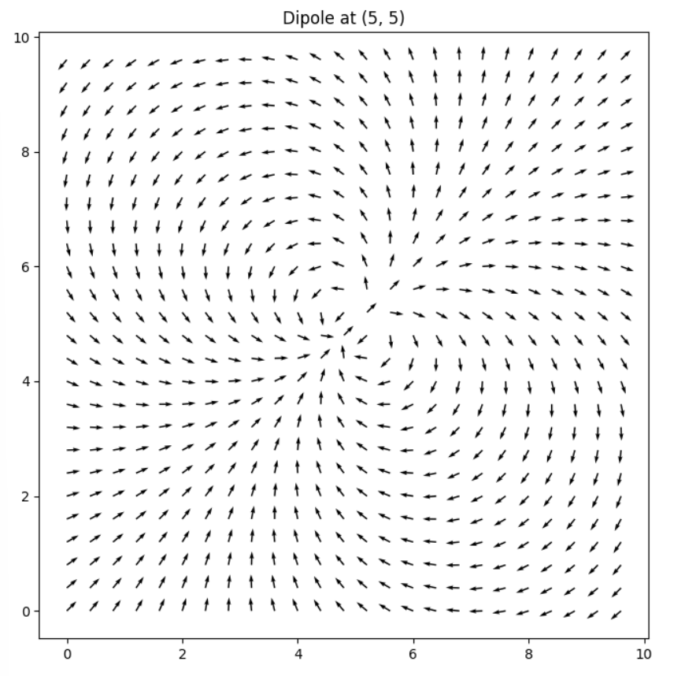
FIGURE 5: VECTOR FLOW FIELD CREATED BY A DIPOLE
When considering boundary conditions with the Laplace equation, it is possible to model flows around a corner, such as a flow along a winding river bed, or flow around an obstacle (see figure 6)
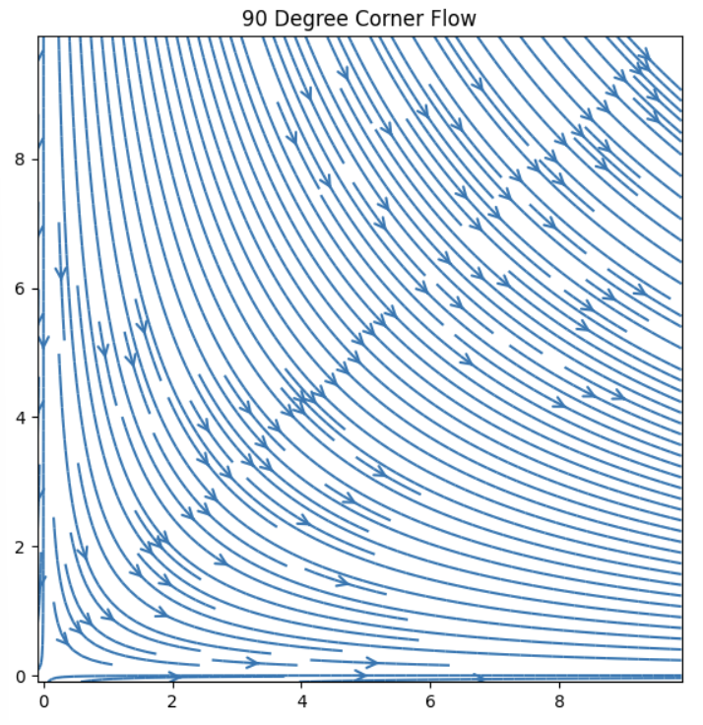
FIGURE 6: FLOW AROUND A 90-DEGREE CORNER
By combining vortices, sinks, sources, uniform flows, and dipoles, more complex vector fields can be created, such as a sinking vortex, a spring in a stream, or co-rotating vortices (see fig 7).
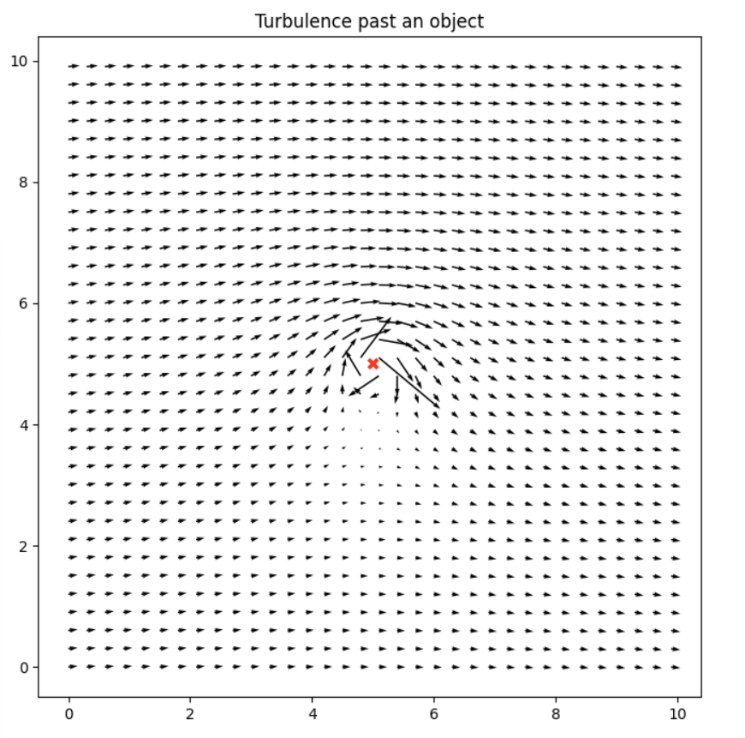
FIGURE 7: VORTEX SUPERIMPOSED WITH A UNIFORM FLOW
Free and fixed vortices can be superimposed to model a Rankine vortex, which simulates the vector flows in a tornado or in a hurricane, as it effectively replicates a pronounced eye that encapsulates a central region of tranquility.
By observing several complex vector fields from combinations of basis vector fields, a list of regions of interest has been compiled. Table 1 describes all interesting features that have been identified, and states which combinations can be used to create them.
Local extrema points such as a sink, source, or sinking vortex have been studied before, and navigating towards them has been demonstrated in both scalar and vector fields. The extrema point can also be the location of the source of a dipole, as the source has the strongest vector magnitude.
Equi-magnitude lines can be thought of as contour lines if a contour plot is made using the magnitude information of a vector field only (see fig 8). Finding an Equi magnitude line could be useful if the individual robots have limitations such as being unable to handle stronger environmental conditions in the vector field beyond some threshold.
The fastest flow in a stream has also been identified as a region of interest. In a magnitude only plot, this would be analogous to a crest. Finding the fastest flow is important, as it correlates to the highest flow rate in a stream for collecting debris or fish.
Stagnations points are areas where the velocity of the vector field is 0. A stagnation point in a vector field may exhibit saddle point behavior, in that it is stable in some direction, and unstable in other directions.

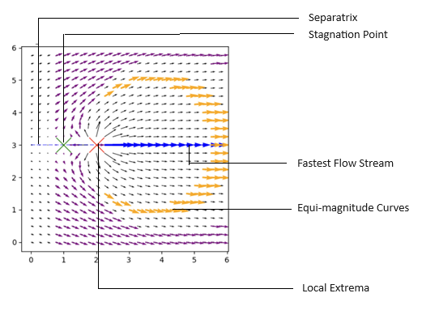
FIGURE 8: SPRING IN STREAM - SOURCE, STAGNATION POINT, FASTEST FLOW, CONSTANT FLOW

Another common feature in vector fields is a separatrix, a curve or trajectory that separates the phase into different dynamics. This can be seen in Figure 9. Following the Vectors below the separatrix point to a clockwise path, while the vectors above the separatrix point in a counterclockwise direction. Moving along a separatrix is analogous to traversing a ridge, as falling off the leads to differing paths of descent..
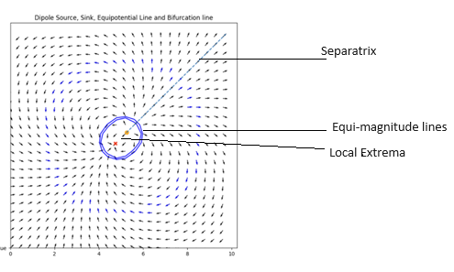
FIGURE 9: DIPOLE FEATURES INCLUDING EQUI MAGNITUDE LINES, EXTREMA POINT, AND A SEPARATRIX
Moreover, combining many flows and incorporating additional flow dynamics such as vorticals, features such as aperiodic orbits, stagnant trajectories, nodes, homoclinic trajectories, and chaotic attractors can be created. These features remain beyond the scope of this research. Furthermore, there may be scalar field regions of interest such as tunnels and overhangs that do not have vector field equivalents that are analogous.

2.3 The Test Bed

Omnibots were the robots used, and their motion was tracked with an OptiTrack System. Note, The Optitrack does not feed information into the reactive controller, it is simply being used as a measuring tool.

3. RESULTS AND DISCUSSION
3.1 Simulation Results
Previous investigation into vector field navigation demonstrated success in navigating towards and around local extrema. It demonstrated this behavior in vector fields of sinks, sources, fixed vortices, and in a sink superimposed with a vector.
The results obtained by [14] were replicated for these instances. Figure 11 demonstrates a three-robot cluster following the average vector direction to the source of a sinking vortex.

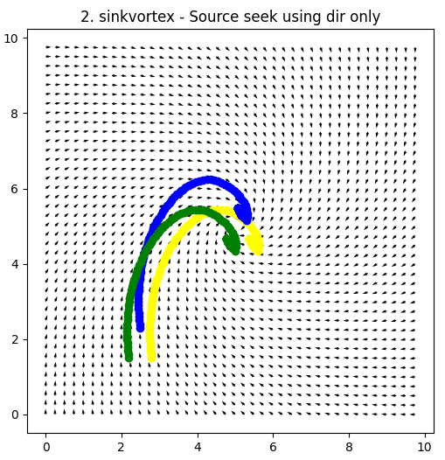
FIGURE 11: SEEKING EXTREMA IN SINKING VORTEX USING DIRECTION FOLLOW TECHNIQUE
By using the vector to scalar technique earlier proposed was also replicated, and it demonstrated to be apt in locating the local extrema points, particularly in sinks and sources or flows that super impose them, such as a sinking vortex. The ‘Vector to Scalar’ technique could also be used to orbit the extrema point by moving perpendicular to the direction of steepest ascent (see Figure 12).
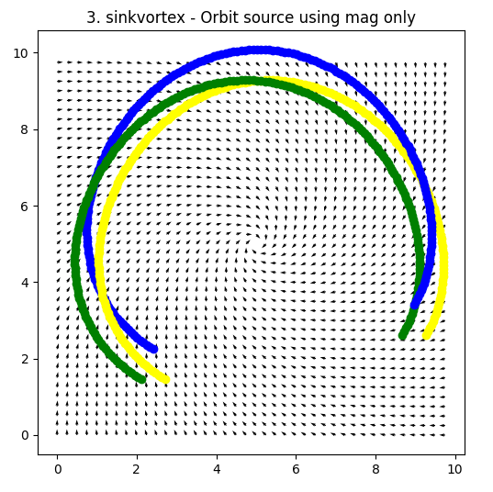
FIGURE 12: ORBITING SINKING VORTEX USING VECTOR TO SCALAR
Previous work has also demonstrated that these primitives can then be used sequentially to perform missions, such as the Fastest Flow Finder Technique. In that mission, they used only direction readings to reconfigure the cluster shape into a straight line, then use magnitude information only to navigate to the fastest flow in a stream moving along 1 axis only.
In contrast to this approach, this work demonstrates the ability to travel to the area of fastest flow without needing to change the cluster shape, nor without the need to use multiple primitives together in a mission. Figure 13 demonstrates the ability to reach the fastest flow of a Rankine Vortex using the vector to scalar technique.
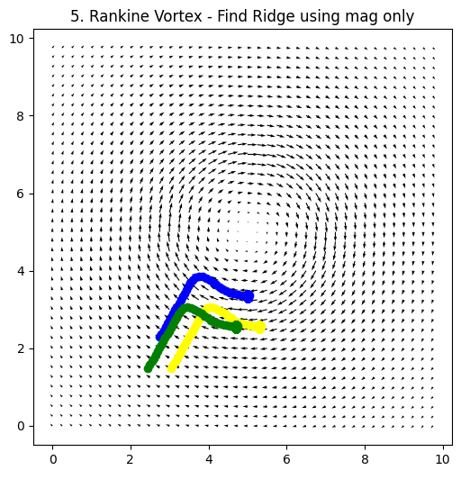
FIGURE 13: FASTEST FLOW OF RANKINE VORTEX
The vector to scalar technique was also used to find the stagnation point. By travelling perpendicular to the angle of steepest ascent, the robot cluster follows a curve that intersects with stagnation point. The results of this simulation can be seen in figure 14.
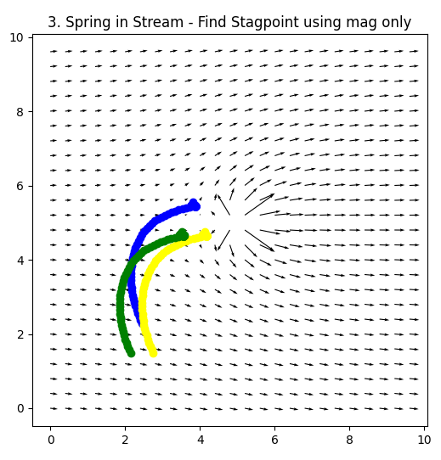
FIGURE 14: FIND STAGNATION POINT IN SPRING IN STREAM.
The nonlinear approach following the vector with the smallest cosine similarity score allowed the robot to traverse the separatrix line. This was demonstrated to work on separatrices associated with dipoles, springs in uniform flows, vortices in streams, and co-rotating vertices. Figure 15 demonstrates a three robot cluster moving against the direction of the vectors while tracking the Separatrix.

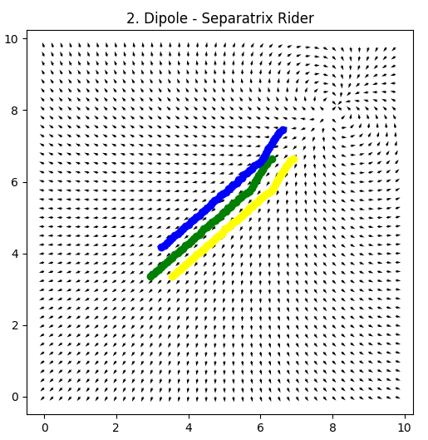
FIGURE 15: MANEUVER SEPARATRIX LINE OF A DIPOLE
The intersecting vector technique was only able to locate extrema in simple fields. Often, there were cases where the vectors were parallel and didn’t intersect, or the intersecting points might not all be in the forward direction. Perhaps this technique could have some threshold for closeness of intersecting points when deciding whether it should be used.

3.1 Future Work
The robustness of these algorithms to noise have not been analyzed. It would be interesting to test them not only with noisy environmental readings, being from the environment or from the sensor readings, but also with non-static environments. The controllers being used also maintain perfect formation. It would be interesting to check if the formation isn’t perfect. It could be worth analyzing the performance changes with different formations and different numbers of robots. This includes redundancy to noise rejection.
These techniques all involve using a centralized architecture. It would be worth extending these capabilities to non-centralized control techniques such as swarms.
Work has been done to create a physical test bed to test robot primitives using RGB cameras and a multicolored floor map. The study concluded that there was not enough resolution between the color channels to be an effective test bed. Testing these primitives on a physical test bed is crucial for evaluating their real-world performance, and work is being done to modify the test bed to enable physical experiments.
The list of regions of interest in table 1 is not exhaustive, and new features may be identified in the future. This work may be extended into 3-dimensional vector fields, which may also have additional features of interest.

4. CONCLUSION
This work successfully models complex vector fields using simpler ones and demonstrates the ability of newly derived primitives to seek newly identified regions of interest using 3 robot clusters. The vector fields were created by finding solutions to Laplace’s equation, and the regions of interest were created using superposition of different solutions. Three new techniques for were developed for three robot clusters, and each was used to maneuver to at least 1 feature of interest.

ACKNOWLEDGEMENTS
This research would not be possible without the funding from Santa Clara University’s Robotic Systems Laboratory.

APPENDIX

Region of Interest | Fields Where Present
Extrema points | Sinks  Sources  Dipoles  Rankine Vortex  Fixed Vortex  Free Vortex  Sink + Vortex  Source + Vortex  Spring in Stream  Opposing Vortices  Corotating Vortices
Equi magnitude Contours | Sinks  Sources  Dipoles  Rankine Vortex  Fixed Vortex  Free Vortex  Sink + Vortex  Source + Vortex  Spring in Stream  Opposing Vortices  Corotating Vortices
Fastest Flow Stream | Corotating Vortices  Superimposed Linear Streams  Spring in Stream  Dipole  Vortex in Stream  Opposing Vortices  Rankine Vortex
Separatrix | Dipole  Vortex in stream  Opposing Vortices  Opposing Streams  Spring in Stream  Corotating Vortices
Stagnation Point | Spring in Stream  Opposing Vortices  Vortex in Stream  Opposing Streams  Superimposed Linear Streams
TABLE 1: REGIONS OF INTEREST IN VECTOR FIELDS

REFERENCES
[1] Gradient-Based Cluster Space Navigation for Autonomous Surface Vessels Thomas Adamek, Member, IEEE, Christopher A. Kitts, Senior Member, IEEE, and Ignacio Mas, Member, IEEE
[2] C. A. Kitts and I. Mas, "Cluster Space Specification and Control of Mobile Multirobot Systems," in IEEE/ASME Transactions on Mechatronics, vol. 14, no. 2, pp. 207-218, April 2009, doi: 10.1109/TMECH.2009.2013943.
[3] I. Mas, S. Li, J. Acain, and C. A. Kitts, “Entrapment/escorting and patrolling missions in multi-robot cluster space control,” in Proc. IEEE/RSJ Int. Conf. Intell. Robots Syst., St. Louis, MO, USA, Oct. 2009, pp. 5855– 5861.
[4] M. Woolsey, C. A. Kitts and M. A. Neumann, "Gradient-based Adaptive Navigation of Multiple Diving Autonomous Surface Vehicles," OCEANS 2022, Hampton Roads, Hampton Roads, VA, USA, 2022, pp. 1-8, doi: 10.1109/OCEANS47191.2022.9977006.
[5] C. A. Kitts and M. Egerstedt, “Design, control, and applications of real world multirobot systems [from the Guest Editors],” IEEE Robot. Autom. Mag., vol. 15, no. 1, p. 8, Mar. 2008.
[6] Lee, Robert K., et al. "3-d adaptive navigation: Multirobot formation control for seeking and tracking of a moving source." 2020 IEEE Aerospace Conference. IEEE, 2020.
[7] S. T. Hart and C. A. Kitts, "Unifying Control Architecture for Reactive Particle Swarms," in IEEE/ASME Transactions on Mechatronics, vol. 28, no. 2, pp. 873-883, April 2023, doi: 10.1109/TMECH.2022.3211155.
[8] Hart, Shae T., Jake Kamenetsky, and Christopher A. Kitts. "Dynamic Elliptical Shaping Control for Swarm Robots." IEEE Access 11 (2023): 17454-17470.
[9] McDonald, Robert T., et al. "Navigation of scalar fronts with multirobot clusters in simulation and experiment." IEEE Systems Journal 14.3 (2020): 3755-3766.
[10] C. A. Kitts, R. T. McDonald, and M. A. Neumann, “Adaptive navigation control primitives for multirobot clusters: Extrema finding, contour following, ridge/trench following, and saddle point station keeping,” IEEE Access, vol. 6, pp. 17 625–17 642, 2018.
[11] Trakas, Panagiotis S., Andreas Tantoulas, and Charalampos P. Bechlioulis. "Formation Control of Nonlinear Multi-Agent Systems with Nested Input Saturation." Applied Sciences 14.1 (2023): 213.
[12] Matveev, Alexey, et al. "Non-Gradient Based Tracking of Environmental Field Isolines in a Changing Medium by Dubins-Vehicle Type Robots." IEEE Transactions on Automatic Control (2023).
[13] Cooper, Ryan, et al. "Initial Study of Multirobot Adaptive Navigation for Exploring Environmental Vector Fields." 2019 IEEE Aerospace Conference. IEEE, 2019.
[14] C. A. Kitts, R. T. McDonald, and M. A. Neumann, “Adaptive navigation control primitives for multirobot clusters: Extrema finding, contour following, ridge/trench following, and saddle point station keeping,” IEEE Access, vol. 6, pp. 17 625–17 642, 2018.
[15] I. Mas, S. Li, J. Acain, and C. A. Kitts, “Entrapment/escorting and patrolling missions in multi-robot cluster space control,” in Proc. IEEE/RSJ Int. Conf. Intell. Robots Syst., St. Louis, MO, USA, Oct. 2009, pp. 5855– 5861.
[16] Wang, J., Guo, Y., Fahad, M., and Bingham, B., 2019, “Dynamic Plume Tracking by Cooperative Robots,” IEEE/ASME Transactions on Mechatronics, early access.
[17] Liddy, Tommie, et al. "Obstacle avoidance using complex vector fields." Proc. of the 2008 Australasian Conference on Robotics and Automation, Canberra, Australia. 2008. – Single Robot with artificial vector field.
[18] Nelson, Derek R., et al. "Vector field path following for miniature air vehicles." IEEE Transactions on Robotics 23.3 (2007): 519-529.
[19] Hu, Bin-Bin, et al. "Spontaneous-Ordering Platoon Control for Multirobot Path Navigation Using Guiding Vector Fields." IEEE Transactions on Robotics (2023).
[20] Braquet, Martin, and Efstathios Bakolas. "Vector field-based collision avoidance for moving obstacles with time-varying elliptical shape." IFAC-PapersOnLine 55.37 (2022): 587-592.
[21] Yao, Weijia, et al. "Singularity-free guiding vector field for robot navigation." IEEE Transactions on Robotics 37.4 (2021): 1206-1221.
[22] Rajabhandharaks, Danop, et al. "Indoor Testbed for Vector Field Multirobot Adaptive Navigation: Feasibility Study." International Design Engineering Technical Conferences and Computers and Information in Engineering Conference. Vol. 59292. American Society of Mechanical Engineers, 2019.
[23] Matveev, Alexey, et al. "Gradient-free tracking of unsteady environmental level sets in dynamic environments by a nonholonomic robot." IFAC-PapersOnLine 53.2 (2020): 9256-9261.
[24] Garg, Kunal, and Dimitra Panagou. "Finite-time estimation and control for multi-aircraft systems under wind and dynamic obstacles." Journal of Guidance, Control, and Dynamics 42.7 (2019): 1489-1505..
[25] Thangavelautham, Jekan, and Yinan Xu. "Co-Evolution of Multi-Robot Controllers and Task Cues for Off-World Open Pit Mining." arXiv preprint arXiv:2009.09149 (2020).
[26] Kalita, Himangshu, et al. "Guidance, navigation and control of multirobot systems in cooperative cliff climbing." arXiv preprint arXiv:1701.07553 (2017)
[27] R. K. Lee, C. A. Kitts, M. A. Neumann and R. T. Mcdonald, "Multiple UAV Adaptive Navigation for Three-Dimensional Scalar Fields," in IEEE Access, vol. 9, pp. 122626-122654, 2021, doi: 10.1109/ACCESS.2021.3107854.

